CONNECTED, LEVEL 4 2015, Is That So?  Reconnecting the Brain  by Bronwen Wall  Overview  This article describes how Dr Melanie Cheung brings aspects of her identity as Māori and her identity as a neurobiologist to the task of seeking solutions for people who live with Huntington’s disease.  Before selecting this article for focus, make sure you are aware of any students for whom this may be a sensitive area of study. Disease and injuries to the brain are more common than many of us realise.  A Google Slides version of this article is available at www.connected.tki.org.nz. |  |  | 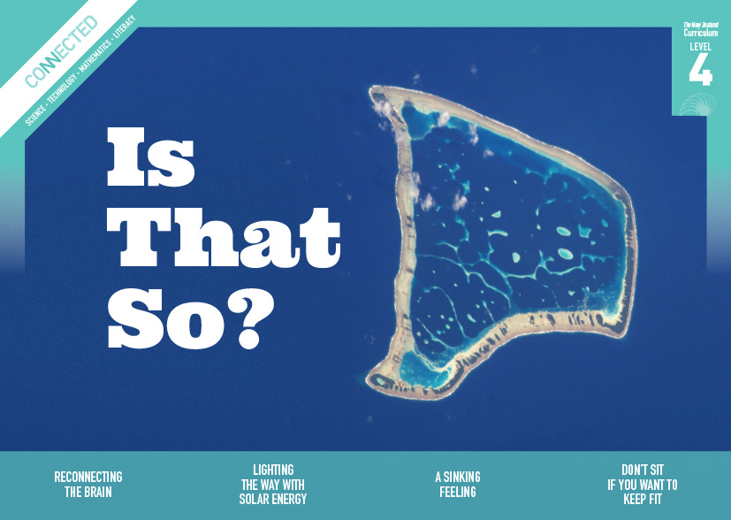  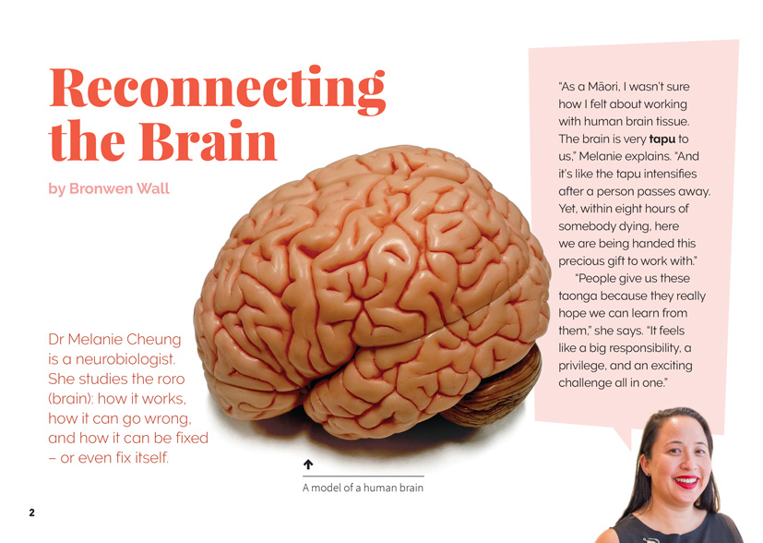
Science capability: Critique evidence |  | Text characteristics

Science knowledge is based on data derived from direct or indirect observations of the natural physical world. An inference is a conclusion drawn from those observations; it is the meaning you make from the observations. Understanding the difference between an observation and an inference is an important step towards being scientifically literate.  Being ready, willing, and able to critique evidence is also an important step towards being scientifically literate. Students must be able to assess the quality and reliability of both the observations (data) and the inferences made from those observations. In order to know what sorts of questions to ask to evaluate the trustworthiness of data, students need both methodological knowledge (how data is generated and collected) and statistical knowledge (how data is collated and analysed).  For more information about the “Critique evidence” science capability, go to http://scienceonline.tki.org.nz/Introducing-five-science-capabilities/Critique-evidence |  | - An informal, conversational voice that speaks directly to the reader and includes humorous plays on language.  - Subheadings, photographs, text boxes, and a glossary to support the text.  - Abstract ideas and concepts that require interpretation.  - Scientific and technological vocabulary and words in te reo Māori that may be unfamiliar to some students.  - Complex scientific ideas and information.

Curriculum context

SCIENCE
NATURE OF SCIENCE: Understanding about science  Achievement objectives  L4: Students will appreciate that science is a way of explaining the world and that science knowledge changes over time.  Students will identify ways in which scientists work together and provide evidence to support their ideas. |  | Key Nature of Science ideas  Scientists:  - evaluate the trustworthiness of data by asking questions about investigations carried out by others  - undertake more than one trial to provide sufficient evidence to support a theory  - replicate investigations to critique the evidence or data provided by other scientists  - check that there are enough samples to reliably establish a conclusion or theory  - look carefully at the way data has been collected when they consider investigations done by others.

ENGLISH

READING  Ideas  Students will show an increasing understanding of ideas within, across, and beyond texts. |  | INDICATORS  - Makes meaning of increasingly complex texts by identifying and understanding main and subsidiary ideas and the links between them.  - Makes connections by thinking about underlying ideas within and between texts from a range of contexts.  - Recognises that there may be more than one reading available within a text.  - Makes and supports inferences from texts with increasing independence. |  | THE LITERACY LEARNING PROGRESSIONS  The literacy knowledge and skills that students need to draw on by the end of year 8 are described in The Literacy Learning Progressions.

Critiquing evidence

The science capability “Critique evidence” is about students evaluating the quality of the data supporting a scientific claim or idea (http://scienceonline.tki.org.nz/Introducing-five-science-capabilities/Critique-evidence).
Scientists use empirical evidence to develop theories about how the world works.
- Empirical evidence is data gathered from observations, experiments, and investigations.
- Scientific claims are only as dependable as the evidence on which they are based.
- Scientists design their investigations carefully to ensure that the data they gather is both reliable and valid. Valid data is data that measures what it is supposed to measure – it answers the research question. Reliable data is dependable and consistent. Replicating the experiment and getting the same results makes us more confident the data is reliable.
- To gather high-quality evidence that is reliable and valid, scientists measure accurately, keep conditions the same or control variables that might influence measurements or observations, repeat tests or investigations many times, investigate multiple examples, and/or use statistical sampling techniques to make their observations or data as representative and accurate as they can.
Students should be critiquing and evaluating the quality of data gathered from their own investigations by:
- engaging in a range of investigation types, exploring, comparing, classifying, identifying, seeking patterns, using models, making things to test ideas, and investigating systems so that they learn different ways to gather different types of data
- identifying ways to make the data they collect in their own investigations as accurate and reliable as possible
- suggesting and developing ways to control conditions or variables or keep things fair, repeating observations or measurements or tests, and developing appropriate sampling methods
- applying their developing understanding of statistics and probability (sampling, variability, randomness, and the exploration of relationships in multivariate data) when making decisions about sample size and repetitions, and when working with their data.
Students should also be encouraged to look for, consider, and critique methods and data underpinning scientific claims made by others. This includes critically examining the appropriateness of methods and the quality of evidence used to develop scientific claims in the media and other sources.
Teachers can:
- help students to be more critical consumers of science information by being explicitly critical themselves
- support students to identify correlations as evidence of a potential relationship, but not necessarily cause and effect
- ask questions such as:
  - Would this always happen?
  - How sure are you of your measurements?
  - How many times should you repeat these tests/measurements?
  - Is this a fair result?
  - What may have influenced the data?
  - Was there a big enough sample?
  - Does the data match the claim?
  - How much variation is there in your results? Why might that be?
- support students to evaluate how data is presented; for example, if data is presented graphically, is this done appropriately or is it misleading? (This draws on another science capability, Interpret representations.)
- support students to apply their understanding of statistics and probability when considering claims, evidence, and data.
- establish a science classroom culture by:
  - modelling and encouraging a critical stance
  - encouraging students to consider the quality and interpretation of data underpinning scientific claims
  - using media headlines to introduce learning conversations and demonstrate the relevance of critiquing evidence to everyday life.
A range of questions and activities designed to get students to critique evidence is available on the Science Online website: http://scienceonline.tki.org.nz/Introducing-five-science-capabilities/Critique-evidence

Meeting the literacy challenges

The literacy demands in this text lie in the integration and synthesis of the information about the brain with the description of the research and work of a scientist (neurobiologist), and the application of tikanga with scientific research. The following strategies will support students to understand, respond to, and think critically about the information and ideas in the text. You may wish to use shared or guided reading, or a mixture of both approaches, depending on the reading expertise of your students or on the background knowledge they bring to the text.
After reading the text, support students to explore the activities outlined in the following pages.

TEACHER resources

Want to know more about instructional strategies? Go to:
- http://literacyonline.tki.org.nz/Literacy-Online/Teacher-needs/Reviewed-resources/Reading/Comprehension/ELP-years-5-8
- “Engaging Learners with Texts” (chapter 5) from Effective Literacy Practice in Years 5 to 8 (Ministry of Education, 2006)
Want to know more about what literacy skills and knowledge your students need? Go to:
- http://literacyonline.tki.org.nz/Literacy-Online/Student-needs/National-Standards-Reading-and-Writing
- http://www.literacyprogressions.tki.org.nz
“Working with Comprehension Strategies” (chapter 5) from Teaching Reading Comprehension (Davis, 2007) gives comprehensive guidance for explicit strategy instruction in years 4–8.
Teaching Reading Comprehension Strategies: A Practical Classroom Guide (Cameron, 2009) provides information, resources, and tools for comprehension strategy instruction.

INSTRUCTIONAL STRATEGIES

FINDING THE MAIN IDEAS
Introduce the text and provide an overview of its content and purpose. Ask questions to help MAKE CONNECTIONS to their prior knowledge.
- What do you think the title of this story might mean?
- What does it mean to reconnect?
- What does the prefix “re-” mean?
- What prior knowledge do you have about how the brain works?
Read the first page and PROMPT the students to notice the focus on feelings and ethics. Have them think, pair, and share their response to these statements:
- “I wasn’t sure how I felt about working with human brain tissue”
- “… it feels like a big responsibility, a privilege, and an exciting challenge”
As they read, have the students use sticky notes to identify other instances of references to feelings or ethical issues.
After reading page 2, have the students conduct a think, pair, share to discover what they know about tikanga. DISCUSS why tikanga might be important to scientists.
Have the students develop a list of questions they would like Melanie to answer about the work she does. Afterwards, have them REVIEW their reading.
- Are any of these questions answered in the text?
- How could you find answers to the questions that were not answered?
After they have read the article, PROMPT the students to think about the inferences they drew from the title about the article’s content.
- What clues in the title suggested what the article was about?
- Was this an effective title?

INTERPRETING ADDITIONAL INFORMATION TO BUILD UNDERSTANDING OF THE TEXT
Have the students SCAN the headings and PROMPT them to notice how they provide clues about the content of the text while also generating interest in the article.
Have the students read the text headed “Kia ora Melanie Cheung”. PROMPT them to notice that this works as a kind of mihi and DISCUSS why the author has done this.
- What does this tell us about what is important to Melanie?
Using a map, you or a student could show the class where Hawaiki is thought to be (somewhere in Eastern Polynesia, possibly Rarotonga or Tahiti) and where the people of Te Arawa have their rohe (see www.tkm.govt.nz/region/te-arawa-waka/). DISCUSS why this information may be important in this article. Return to this discussion when the students read the final page.
Have the students look closely at the image comparing the brain of a person with Huntington’s disease with a healthy brain.
- What differences do you notice?
- How does the image help you to understand the explanation in the text?

DEALING WITH ABSTRACT IDEAS
ASK the students to look across the whole text to identify, examine, and summarise the main ideas in this text.
How does Melanie use both Western science ideas and a Māori world view in her scientific work?
Have the students use the following graphic organiser to record what they have learned about tikanga and neuroplasticity and to integrate and synthesise this information to make a statement about how Melanie brings them together in her work as a neurobiologist.
Ideas about tikanga
Ideas about neuroplasticity
How Melanie brings these ideas together
PROMPT the students to consider and evaluate the statement, “Māori have been scientists throughout time …”
- What does this quote from the article mean?
- What examples can you find to back up this statement?
In pairs, have the students share where they placed their sticky notes (from Finding the main ideas) and why. Use this as a catalyst for discussion about what motivates somebody to be a scientist and the sorts of ethical dilemmas that scientists may encounter. ASK QUESTIONS that support the students to move from an abstract discussion of these issues to an understanding of how they impact upon the students.
How does Melanie feel about her work? How have those feelings impacted upon her career?
Have you experienced similar feelings to Melanie? How have they affected your thinking about science?
Have you had experiences that have motivated you to take an interest in science … or turned you off science?
If you could choose any area of science to study, what would it be? Why?
How do you feel about the idea of dissecting a human brain? Do you think it is ethically justified? Why or why not?
What other examples can you think of where there is debate about whether people should be engaging in scientific study? (Examples might include genetic engineering of food crops or the creation of “test-tube babies”.)
- Do non-scientists have a right to take part in these debates? Why or why not?
The students might follow this discussion up with research into career options in science or into the pros and cons of a particular ethical issue.

DEALING WITH UNFAMILIAR VOCABULARY
PROMPT the students to locate meanings for unknown words and phrases by using the text, contextual clues, and the glossary on page 8. Have them create a class word wall showing new vocabulary in the text, including definitions to explain word meanings.
PROMPT the students to notice that there is a group of words in the article that all begin with the prefix “neuro”. “Neurons”, “neurodegenerative disease”, and “neuroplasticity” are all defined in the glossary and “neurobiologist” is defined within the first sentence of the article. Have the students pull apart the prefixes and their root words to see how they are constructed. The definition in the final column should be in their own words, not a copy from the text. They will need to use dictionaries to complete this activity.
“Neuro” means …  “Neuron” means … | “Degenerative” means …  “Disease” means … | So “neurodegenerative disease” means
 | “Plasticity” means … | So “neuroplasticity” means …
 | “Biologist” | So “neurobiologist” means …
Words with multiple meanings can be confusing, especially for students who are English language learners. An example in this text is the word “organ”. Have the students research the meanings of this word and write sentences that demonstrate its correct use. They can then peer-review them, selecting the best examples for the class word wall.

DEVELOPING SCIENCE-SPECIFIC LITERACY
Give the students an example of a formal scientific report that is written in the third person and has a title, abstract, introduction, methods section, result and findings section, and conclusion. Have them compare this with the structure and language of the text in “Reconnecting the Brain”. DISCUSS the idea that scientific information can be communicated in a variety of ways that is related to the audience and purpose. Scientists do not just talk to each other. They also need to talk to other people about:
their process, as Melanie did in discussing the tikanga of working with the human brain
what their findings mean, as in Mike Merzenich’s discovery that our brains can continue to change after the age of eighteen
how their findings can be translated into action, as in the example of the Māori whānau living with Huntington’s who have signalled their willingness to “give neuroplasticity a go”.
There are commonalities in scientists’ use of language and structure when they are sharing or communicating ideas and information for all audiences and purposes.
Return to the analysis, completing the next two rows in the graphic organiser below. The students might then add further columns to the template, exploring other ways in which scientific information can be communicated. Remember that these are not just paper-based – scientists share information through a rapidly expanding range of media, including film, exhibitions, drama, multimedia publications, and art installations. Ask the students to identify the commonalities between these two articles.
 | “Reconnecting the Brain” | Example: Scientific report
Audience
Purpose
Structure
Language
The students could retell Melanie Cheung’s story for a specific audience and purpose. Alternatively, they could investigate how the brain controls the body and decide how they will share what they found out with a particular audiences. You could suggest that the students investigate ReadWriteThink’s “Student Interactive: Printing Press” (http://www.readwritethink.org/classroom-resources/student-interactives/printing-press-30036.html), which offers a variety of interactive resources students could use if they wish to create a newspaper, informational brochure, flyer, poster, or flip book.

Teacher support
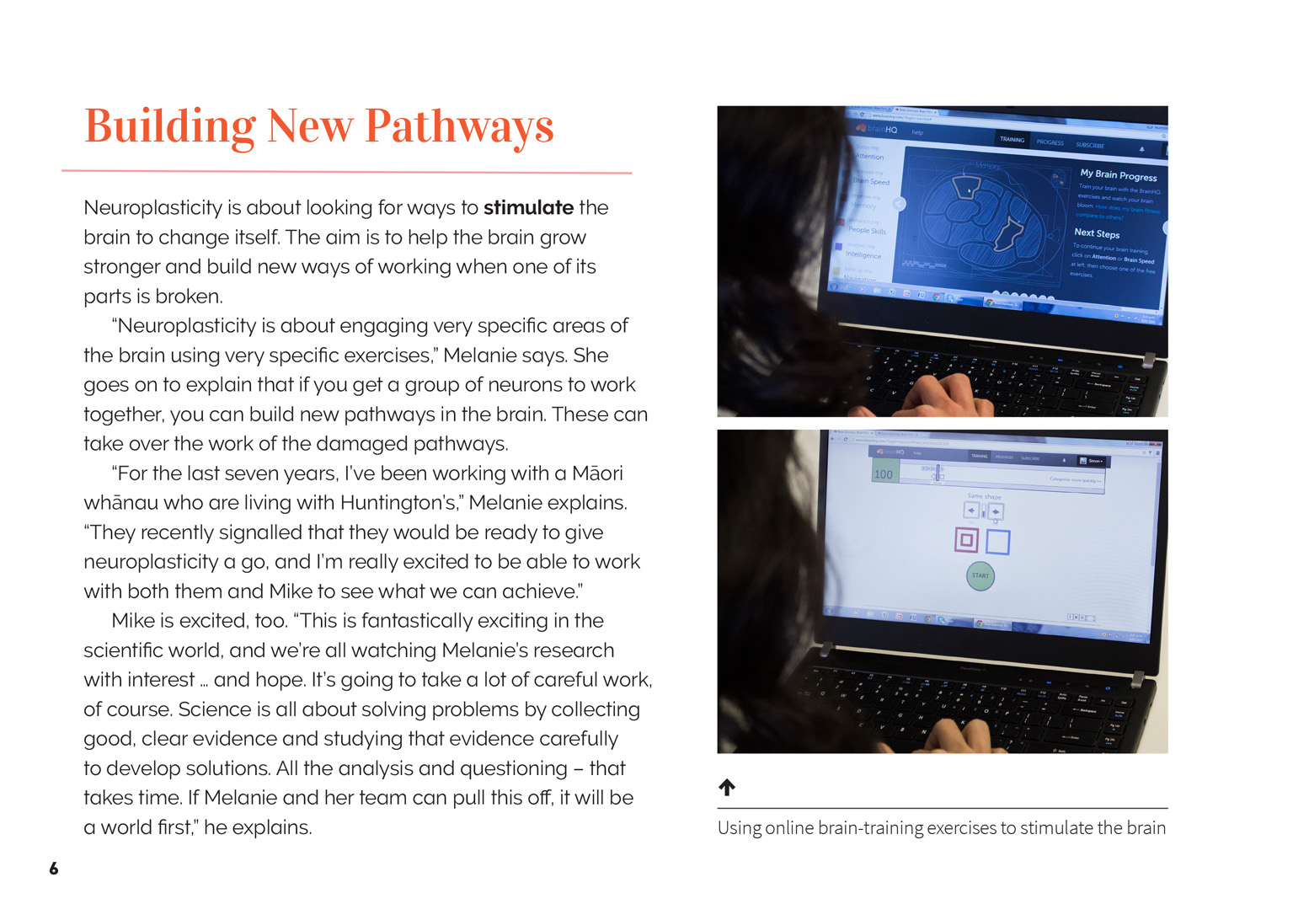 | Scientists use evidence to develop theories about how the brain works.  Scientists evaluate the trustworthiness of data by asking questions.  Scientists gather enough samples to reliably establish a conclusion or theory.  Scientists work together to gather evidence to support ideas.

Learning activities
The following activities and suggestions are designed as a guide for supporting students to explore and develop understandings about the science capability “Critique evidence”. Some activities focus directly on the science capability. Other activities extend student content knowledge across the learning areas. You are encouraged to adapt these activities to support your students’ learning needs.

Exploring the science

Activity 1: Brain-training inquiry
This article does not provide the opportunity to critique evidence that other items in this Connected offer, but it does create opportunities for students to ask and answer critical questions. Begin this activity with discussion of the following questions:
What did scientists originally think about the brain’s ability to grow and change?
Why do you think scientists did not initially believe Dr Mike Merzenich’s suggestions about neuroplasticity?
Do you think just one piece of evidence should change a long-standing scientific theory or explanation?
What kind of evidence would scientists working in this area require to change their ideas?
The students could consider these questions while investigating reports on some of the approaches that have been tried. There are examples in the resource links, including “Neurofeedback: Controversial brain treatment divides experts” (www.stuff.co.nz/life-style/well-good/teach-me/65267240/neurofeedback-controversial-brain-treatment-divides-experts) and a video of Barbara Arrowsmith Young, the woman who not only changed her own brain, but developed a technique that has subsequently been used by many other people around the world, including in New Zealand (www.barbaraarrowsmithyoung.com/television/).
Focus the students upon the question for inquiry: “How can we teach our brain to do new things?” Have them generate a hypothesis and set up simple experiments to test whether it is true, for example, “If I practise and test my [x] times table every day for [x] minutes, I can improve my ability to do the [x] times table.” They could also try the brain-training exercises suggested in the resource links. The students will need to collect, display, and evaluate their data.
In discussion, challenge the students to be accountable for their findings:
What are the steps in your scientific procedure?
What rules did you follow?
What are the advantages of this exercise? Can you provide some evidence?
Afterwards, the students could consider what they have learned about the importance of maintaining an active brain.
Who would benefit from learning about this?
What would be a good way of communicating the information?

Activity 2: Communicating about the brain
View “The Brilliant Brain Cell Show” as an example of an effective and interesting way of communicating scientific information.
Working in groups, the students could then research different aspects of brain research in New Zealand, selecting from one of the topics listed below. Their task is to communicate factual, scientific information to the rest of the class in a manner that engages their interest. Return to the discussion of scientific literacy and have the students co-construct a rubric for evaluating the presentations.
When you are reading or viewing scientific presentations, what is it that captures your interest?
What do you need to see, read, or hear to be convinced of the credibility of the information?
What sort of thing would stop you paying attention or believing in the validity of the information?
Potential topics include:
finding out more about Melanie Cheung and the work she does
the different aspects of research into the brain being carried out at the Centre for Brain Research at the University of Auckland
Brain Day and Brain Awareness Week, which are held in March each year
Professor Richard Faull, the New Zealand scientist who started the Human Brain Bank, and what the Brain Bank does.
Have the students use their rubrics to evaluate the quality of their presentations. Then have them reflect on their learning, thinking about what they want to remember for future presentations of their learning in science.

Activity 3: Putting our brains together
Use a viewing of the “The Brilliant Brain Cell Show”, a performance by Room 23 at Rototuna Primary School, written and directed by Dr Melanie Cheung, to provide the students with some background information about the structure of the brain and the function of different cells within it. Have them investigate further and draw up diagrams of the brain, identifying what is controlled by which parts of the brain.
Move from this to an inquiry into a range of neurological diseases and their causes, effects, and treatment. Examples include Alzheimer’s, Parkinson’s, motor neurone disease, stroke, multiple sclerosis, migraine, and epilepsy. The students could create a shared template for profiling the diseases and then break into groups to conduct the research needed to complete the profiles, with each group focusing on a particular disease. You should co-construct the template with the students, but they might include headings for the following:
Name of disease:
Symptoms:
Cause:
Diagnosis:
Management:
Avoidance (if possible):
Significant scientific breakthroughs:
Ethical issues:
As the students complete their investigations, encourage them to think about how well they are communicating the information. Afterwards, have them share their profiles with each other so that everyone gets an overview of the diseases that were investigated.
Discuss what the students have learned about how people cope with these diseases and how science and the community can help:
How is science supporting people with brain diseases?
What can friends and whānau do to support people with brain diseases?
What might people in the wider community do to support people with these diseases? What about support for those who care for them?
Extension
The students could investigate brain health and identify ways that we can look after our brains, stimulate the brain, and avoid head injury. They could think about who needs to know this information and explore an appropriate way of communicating it.

RESOURCE LINKS

Background information for teachers
“Four Common Sense Tenets of Brain-Based Learning” from ASCD. www.ascd.org/ascd-express/vol10/1016-schopf.aspx
Gray, A. (2000). Huntington’s and Me: A guide for young people. Huntington’s Disease Association: Wellington. This book provides useful information for young people who are learning to cope with Huntington’s in their family.
“Inside the brain of a struggling reader: Why a one-size-fits-all approach does not work for every child” from District Administration. www.districtadministration.com/article/inside-brain-struggling-reader
“Strengthening Connections in a Brain-Friendly Classroom” from ASCD. http://www.ascd.org/ascd-express/vol10/1016-kappus.aspx

More on Melanie Cheung
“A career with moments of pure magic” from New Zealand Science Teacher. www.nzscienceteacher.co.nz/putaiao/a-career-with-moments-of-pure-magic#.VOFfevmUfRI
“Celebrating Women Series – Dr. Melanie Cheung” from Mindfood. www.mindfood.com/video/celebrating-women-series-dr-melanie-cheung/
“Dr Melanie Cheung – Chur Ep.3” from Totes Māori, TVNZ. https://www.youtube.com/watch?v=KrVTdXXLJ48
“Melanie Cheung – Neurobiologist” from Māori Futuremakers. www.maorifuturemakers.com/melanie-cheung-neurobiologist

Science Learning Hub
“Brains” http://sciencelearn.org.nz/Science-Stories/Ever-Wondered-Series-2/Brains
“Understanding brain development” http://sciencelearn.org.nz/Contexts/Uniquely-Me/NZ-Research/Understanding-brain-development
“Functional MRI looking at the brain over time” http://sciencelearn.org.nz/Contexts/See-through-Body/Sci-Media/Video/Functional-MRI-looking-at-the-brain-over-time
“What is normal?” http://sciencelearn.org.nz/Contexts/See-through-Body/Sci-Media/Video/What-is-normal
“Making connections in the brain” http://sciencelearn.org.nz/Contexts/Exploring-with-Microscopes/NZ-Research/Making-connections-in-the-brain

Other sources
“Aristotle on the Brain” from the Neuroscientist. https://www.princeton.edu/~cggross/Neuroscientist_95-1.pdf (an article from 1995 examining Aristotle’s ideas about the function of the brain)
“Barbara Arrowsmith Young: The Woman Who Changed Her Brain” from TEDx. www.barbaraarrowsmithyoung.com/television/ (video)
“Brain Day Video” from the Centre for Brain Research. www.fmhs.auckland.ac.nz/en/faculty/cbr/brain-day-2015/what-is-brain-day.html
Brain Injury Support www.brain-injury.org.nz/index.html
Brain HQ (brain-training exercises) www.brainhq.com
Centre for Brain Research at the University of Auckland www.fmhs.auckland.ac.nz/en/faculty/cbr/our-research/research-teams.html#e9d4473edb8998f2d0ebd5a59f67154
“Explore the Brain and Spinal Cord” from Neuroscience for Kids. http://www.dls.ym.edu.tw/neuroscience/introb.html (provides detailed information on the parts of the brain)
“Milestones in Neuroscience Research” from Neuroscience for Kids. https://faculty.washington.edu/chudler/hist.html (a timeline of important events in the development of neuroscience)
Nancy’s brain talks. http://nancysbraintalks.mit.edu/
“Neurofeedback: Controversial brain treatment divides experts” from Stuff.co.nz. www.stuff.co.nz/life-style/well-good/teach-me/65267240/neurofeedback-controversial-brain-treatment-divides-experts
“Neurological Foundation of New Zealand: Human Brain Bank” www.neurological.org.nz/what-we-do/human-brain-bank
Neuroscience for Kids: homepage. http://faculty.washington.edu/chudler/papy.html (describes the first written mention of the word “brain”)
“Retraining the Brain: Harnessing our Neuralplasticity” www.janinafisher.com/pdfs/neuralplasticity.pdf
“Student Interactive: Printing Press” from ReadWriteThink. www.readwritethink.org/classroom-resources/student-interactives/printing-press-30036.html
“The Brilliant Brain Cell Show” written and directed by Dr Melanie Cheung. http://vimeo.com/50663802
“The Secret Life of the Brain” from PBS. www.pbs.org/wnet/brain/history/index.html (a walk through the history of research into the workings of the brain)
“What is the history of Huntington’s disease (HD)?” from Huntington’s (New South Wales). www.huntingtonsnsw.org.au/information/hd-facts/history (an informative webpage outlining the history to understanding Huntington’s disease)

Google Slides version of “Reconnecting the Brain” www.connected.tki.org.nz

